Gizmoball3D
Implementation and Critique

Team: se042
David Tsai
Eric Tung
Ragu Vijaykumar

TA: Stefanie Tellex

May 13, 2003
I. Requirements

1.1 Overview

Gizmoball is an adaptation of pinball, an arcade game in which the object is to keep a ball moving around the playing space without falling off the bottom of the game. Gizmoball extends the functionality of pinball by allowing players to create their own custom playing fields, as well as specify specific triggers between specific game pieces.
The layout of the game consists of one overall graphical user interface. However, the user interface is constantly modified based on whether the user is in the editing mode of the program or the simulation mode of the program. This toggle buttons between these two modes are the play and stop buttons, where play will switch the user to the simulation mode and the stop button will switch to back to the editing mode of the game. The environment of the game is set to model physical reality, with configurable gravity vectors and coefficients of friction. These environment variables directly affect the trajectory of the ball in the playing space and hence simulate the ball in an actual physical space. Also, balls will collide with other objects in the playing space, as well as the boundaries of the playing space if boundaries are provided. Conservation of momentum is established in the playing space, with gizmos have a mass that can be considered infinite when compared to the ball.
Users may also pause the game at anytime and switch perspectives to view the action of the game from different angles. The effect of pausing the game is that all pieces of the board are “frozen” to their current location, and no further simulation is run. All games are able to be saved and loaded to a local disk.

1.2 Revised Specification

1.2.1 Pieces

There are seven default pieces that can be used in the game: Absorber3D, Ball3D, CubicalBumper3D, Flipper3D, OuterWall3D, SphericalBumper3D, TriangularBumperA3D, TriangularBumperB3D, TriangularBumperC3D, and Jezzmo3D. These pieces are three dimensional analogs of the pieces in the original specification of Gizmoball. Flippers can be rotated to function as either left flippers or right flippers. The default coefficient of reflection for all pieces is 1.0, except for flippers, which is 0.95. These parameters can be configured by the user.

1.2.2 Playing Space

The playing space is a 3 dimensional space that represents the playing field. The playing space is able to be resized to any dimensions; however, it must remain a rectangular prism. The default size of the playing field is 20 L by 20 L by 20L, for a total of 8000 possible positions to place gizmos and balls. The origin of the space is located in the lower-right hand corner, as seen in Figure 1. In addition, the playing space is complemented by a set of environmental parameters, namely a gravity vector and two coefficients of friction. By enabling a gravity vector, the user is able to specific not only the magnitude, but also the directionality of gravity in the 3-dimensional playing space. The default gravitational vector is -25 L/sec² in the y direction and the default coefficients of friction are μ₁ = 0.025 sec⁻¹ and μ₂ = 0.025 L⁻¹.

1.2.2.1 Editor Mode

The program begins by entering the edit mode for the user. In this mode, the user is able to add, delete, and configure pieces on the board. All pieces snap to the grid that is displayed. The user is also able to configure environmental variables, such as the magnitude and direction of gravity in the playing space, and the coefficients of friction. All pieces are given wire-frames and bounding boxes that represent their range of influence in the playing space. Pieces whose ranges of influence are overlapping are displayed to the user as bright red bounding boxes. The play button is disabled until all pieces are in valid locations. The user is also able to create triggers between gizmos and input connects that perform specific actions during simulation mode from keyboard / mouse input.

1.2.2.2 Simulation Mode

Once the play button is hit, the program switches to the simulation mode and begins to activate the physical environment. All environmental parameters influence the ball in it’s trajectory around the playing space, and gizmos are able to trigger one another after collision with a ball. The user may interact with the simulation by key/mouse presses that trigger specific actions as configured in the edit mode. The simulation runs at 34 frames per second, but this setting can be changed in the Arena Properties dialog box found in the menu. Details of how the physical parameter of all balls in the playing space are altered is given in Section 3.2. The user is able to switch perspectives in the simulation mode, as well as pause, stop, or replay the animation.

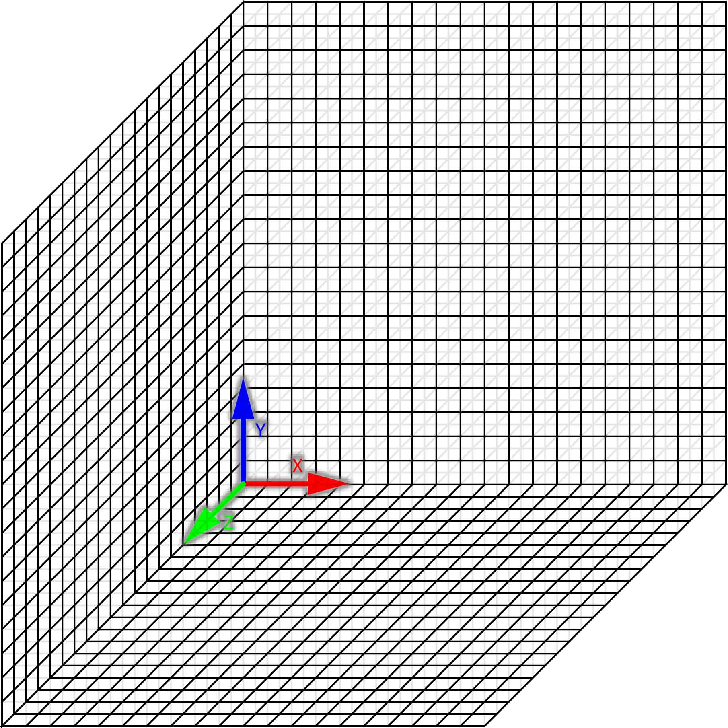

Figure 1: Playing Space and the directionality of the positive axes. The intersection of the three axes represents the inner bottom left corner of the rectangular prism.

1.2.3 Save / Load

In light of the modified specification to the playing, we still provide access to loading files of the standard 6.170 Gizmoball file format into the 3D playing space. However, playing spaces may only be saved to the g3d format, which is yet to be completely determined.

1.2.4 Extra Features

There are several optional features that have been added to the program. Mouse-overs explaining the button functionality have been added, along with visual clues as to which button is to be clicked. Perspective buttons have been added to view the playing space from a variety of different angles. In addition to the physically seen features, improvements have been made to the engine processor to provide smooth animation for up to 50 balls and 400 gizmos simultaneously.

1.3 User Manual

The user manual can be found in Appendix E at the end of the documentation. Below is a screenshot of the user interface.

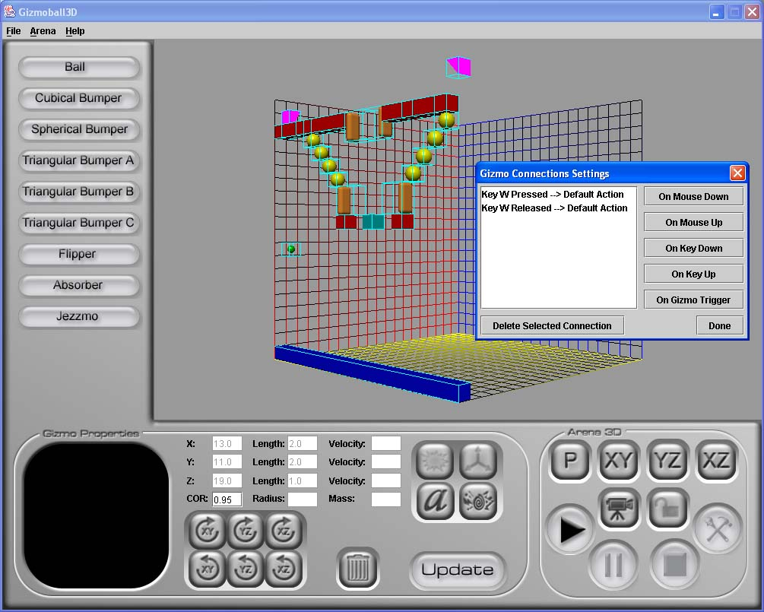
Figure 2: The graphical user interface of Gizmoball3D.

1.4 Performance

Due to the 3-dimensional simulation of our Gizmoball implementation, many of the modules are highly optimized for memory and time management. Since there are significant more possibilities for trajectories of balls and actions that happen during the simulation, more weight was given to speed optimizations than memory optimizations. These optimizations are handled by the simulation engine and are varied dynamically by the engine to give the smoothest animation possible while minimizing time and memory concerns. One key design implementation is the minimized amount of calls to the garbage collector by not creating and destroying memory-loaded objects frequently in the engine. The amount of memory consumed for m balls and n gizmos is approximately O(m+n) while the amount of time consumer is O(m² + kmn), which k is the percentage of gizmos in a ball’s trajectory.

1.5 Problem Analysis

The problem object model shown in Figure 3 is a conceptual model of the Gizmoball application. Note that this object model was made to encapsulate Gizmoball the game, regardless of whether it is 2-dimensional or 3-dimensional. The underlying problem is still the same, with 3-dimensional labeled items being replaced by their 2-dimensional counterparts, i.e. Canvas instead of Canvas3D.

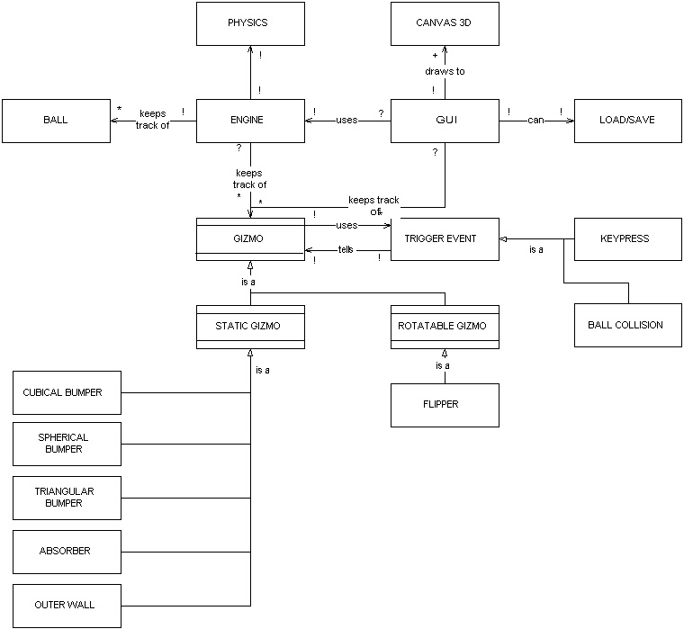

Figure 3: Problem Object Model for Gizmoball

II. Design

2.1 Overview

The Gizmoball software system is divided up into 5 separate modules: backend, engine, gui, physics, and plugins. Each module was chosen to be completed by a different team member and designed such that each could work at his own pace without having to depend on the progress of another team member. This also ensured maximum modularity and decoupling, as each team member was forced to set up only minimal connections to other modules in order to gain full functionality of the software. A brief overview of each module is given below:

- Backend – The backend package actually contains two modules and a collection of interfaces that can be used to create pieces of different types. The two modules are the event module and stream module, with all interfaces stored in the top level backend package.

  - Types: Interfaces used to create all the types of pieces that can be implemented by piece plugins.

  - Event: This module handles events that the user specifies and casts the necessary messages to all gizmo listeners. Currently the only type of events it listens for are key events and mouse events.

  - Stream: This module contains all the interfaces and classes needed to accurately load and save files of varying formats.

- Engine: This module is used to apply a 3d physics package to the Gizmoball system. It also decouples itself from the rest of the system by providing a set of interfaces for pieces to use in order to achieve full-functionality with the engine.

- Graphical User Interface (GUI): This module contains the classes used to create a user interface, as well as facilitate facile user interaction for the software. Specific actions of the graphical user interface are to properly handle mouse behaviors and keyboard/mouse input and transfer that information to the necessary parts of the software in a clean and modular fashion.

  - Backend: This module contains interfaces for proper functionality with the graphical user interface. Classes that implement interfaces in here are guaranteed to work properly with the graphical user interface.

- Physics: This module is used to simulate real-time physics in a 3-dimensional environment. Methods from this package are used directly by the engine to simulate the physical environment of the playing space. The package decouples the implementation of playing-field physics from the rest of the software system.

  - Backend: This module contains interfaces for proper functionality with the physics simulation engine. Any classes that implement the non-abstract interfaces are guaranteed to be simulated correctly by the simulation engine.

  - Exceptions: This module contains all gizmo-physics specific exceptions

- Plugins: This module contains all the actual gizmos themselves, as mentioned in Section 1.1.1, as well as all the pre-defined game-play modes that can be initialized. By having gizmos as plugins, we have inherently decoupled them from the rest of the modules since to work properly, all they must do is implement communicator interfaces of each of the modules.

To promote the modularization of our software, several design patterns were used. These design patterns are described in the implementation section.

2.2 Runtime Structure

The runtime structure is illustrated below in Figures 5-10 on the following pages. Abstract interfaces define a type for existing objects, but should not be directly implemented. Domains, relations, and constraints are all listed below:

2.2.1 Constraints

  - No two pieces may have overlapping wire frames at any time during the simulation.
  - All pieces must implement any of the concrete interfaces to function correctly. It is not enough to implement the abstract-declared interfaces.

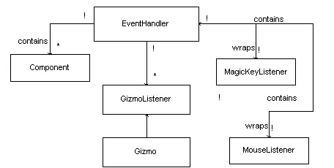

Figure 4: Event Code Object Model

  - EventHandler: A mediator between gui components and the gizmos themselves for setting up user input interactions
  - GizmoListener: An interface used to communicate with gizmos

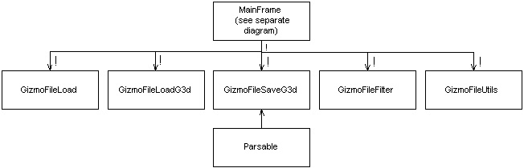

Figure 5: Stream Code Object Model

Parsable: An interface specifying how a piece may convert its internal state into a string representing that information

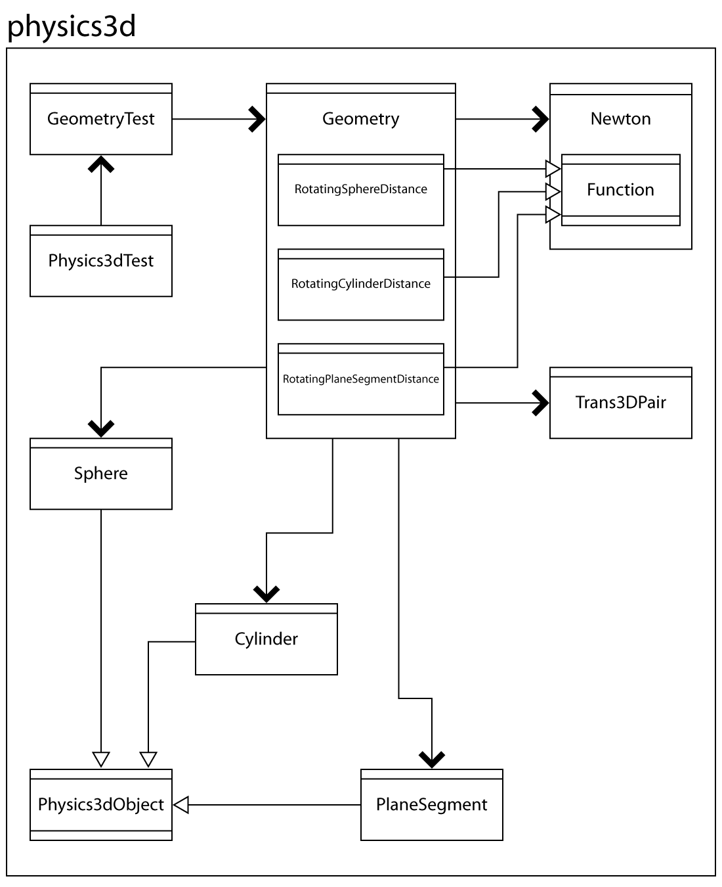

Figure 6: Physics Code Object Model

  - Geometry: A class containing static methods on processing how collisions occur between different physical objects, such as the time until collisions between a sphere and any other object, and how the system reacts after the sphere collides with a physical object.

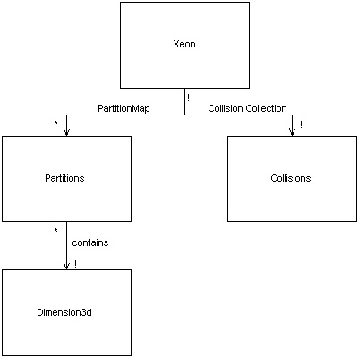

Figure 7: Engine Code Object Model

  - Xeon: A static engine that simulates the physical environment in the playing space
  - Collisions: A class that collects and stores information related to all collisions that occur during periods between animations
  - Partition: A class modeling a subset of the space represented by a rectangular prism to the engine
  - PartitionMap: partitioning of the playing space by the engine

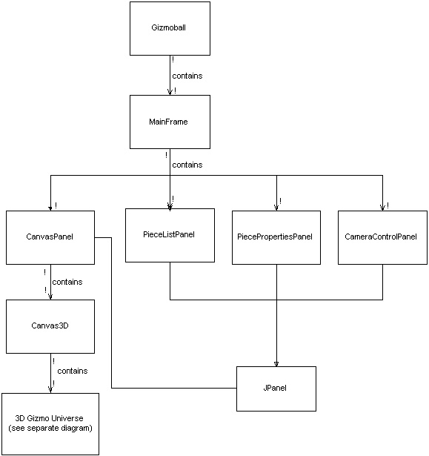

Figure 8: Graphical User Interface Code Object Model

  - GraphicArena: A GUI canvas object that represents the editor and simulation view of the game

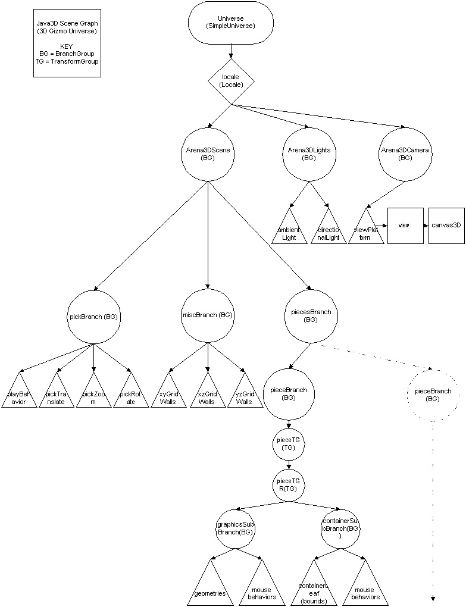

Figure 9: J3D Scene Graph Code Object Model

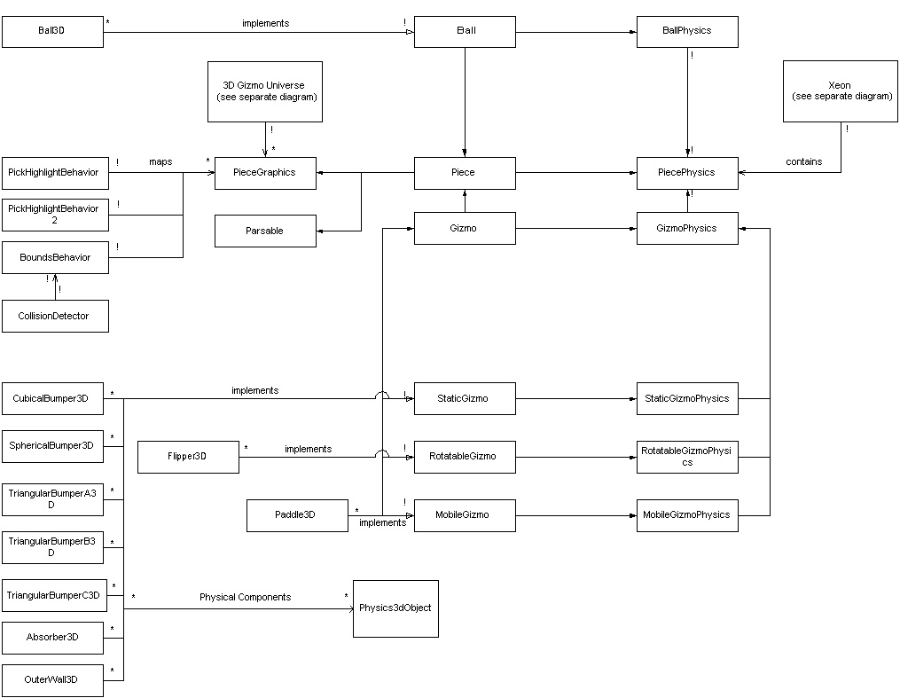
Figure 10: Plugins Code Object Model

  - Piece: An abstract interface specifying methods that are inherent to every piece on the board
  - Ball: A sub-interface of piece specifying additional methods that are applicable to generic balls.
  - Gizmo: An abstract interface specifying methods that are common to all gizmos in the playing space.
  - StaticGizmo: A sub-interface of Gizmo for non-moving gizmos
  - RotatableGizmo: A sub-interface of Gizmo for rotating gizmos within their bounding box
  - MobileGizmo: A sub-interface of Gizmo for translational moving gizmos within their bounding box
  - PieceFactory: An interface providing methods to produce factory classes for gizmos
  - PieceGraphics An interface specifying what methods must be implemented for pieces to be accurately drawn by the gui
  - PiecePhysics: An abstract interface specifying what physical methods are common to all objects in the playing field
  - BallPhysics: An interface specifying the physical principles governing all balls in the playing space
  - GizmoPhysics: An abstract interface specifying the physics governing all gizmos.
  - StaticGizmoPhysics: An interface designed to model gizmos that will not move with velocity during the course of the game.
  - RotatableGizmoPhysics: An interface designed to model gizmos that will only move with angular velocity during the course of the game.
  - MobileGizmoPhysics: An interface designed to model gizmos that will only move with translational velocity during the course of the game.
  - Balls: list of balls in the playing space
  - Gizmos: list of gizmos in the playing space
  - Physical Components: The 3d physical objects that comprise the wire-frame of this object

2.3 Module Structure

The module dependency diagram is illustrated below in Figure 11.
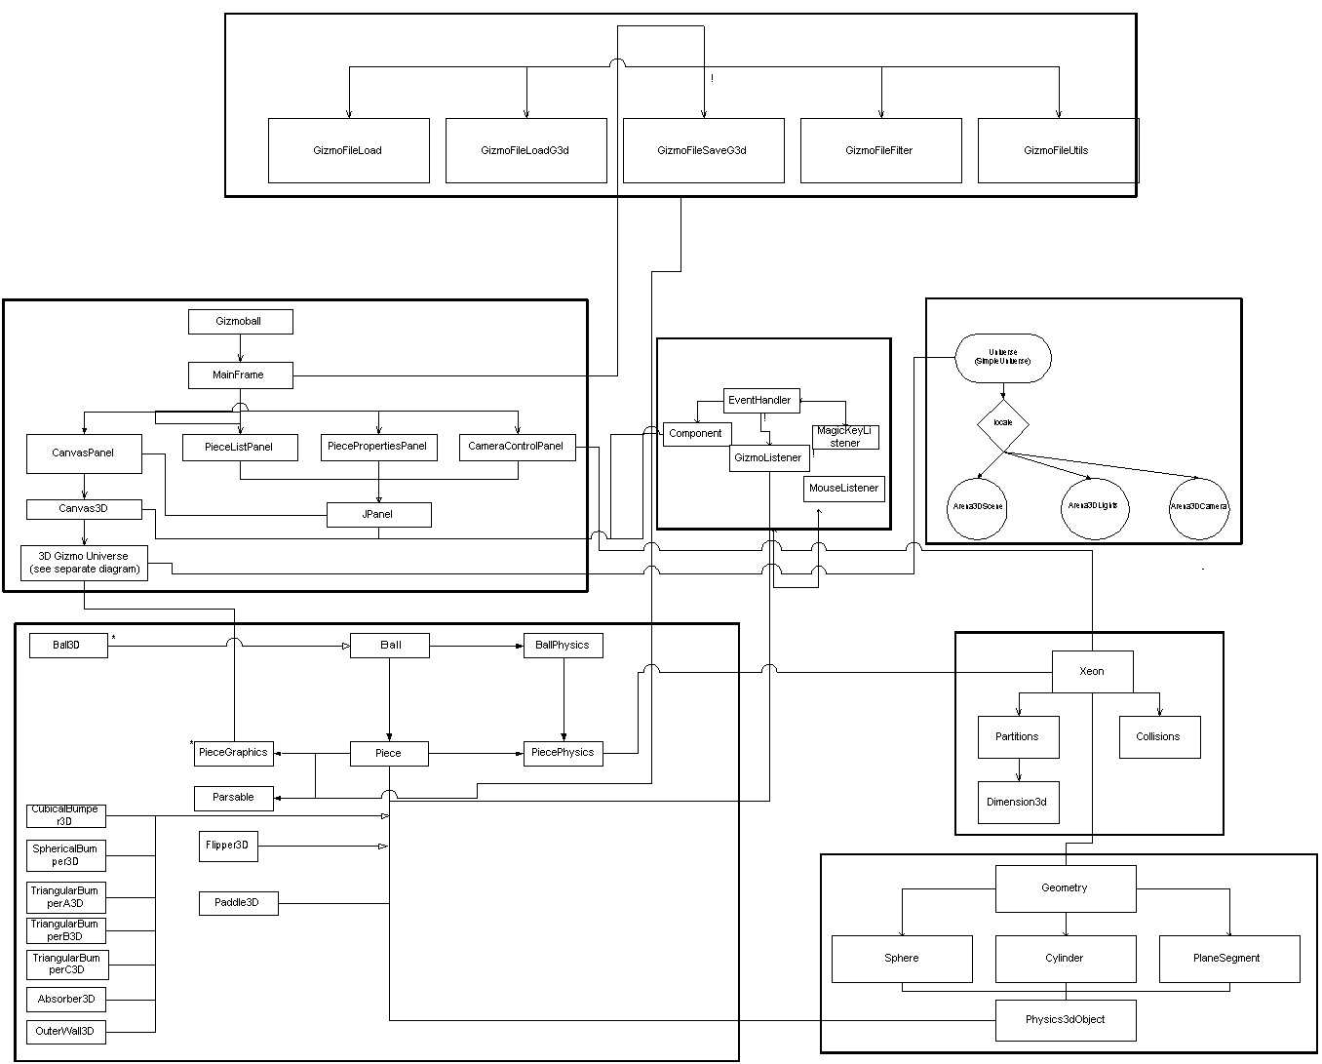
Figure 11: Module Dependency Diagram

2.4 Design Changes

The release of the amendment caused us to have to make some small design modifications to our system. Multiple balls had already been supported; however, due to the complex graphical rendering of our system, animation is significantly impaired after 450 pieces are added to the board with a system running at 35 frames / sec. The key handling system was not adequately decoupled, so we made modifications to it such that gizmos would not have to implement interfaces for every type of input. Instead, we created our own event and multicast classes, similar to InputEvent and AWTEventMultiCaster, which would handle inputs and communication between the user and gizmos, and gizmo-gizmo connections. This required the use of a new interface, GizmoListener, that gizmos implement if they want to be able to communicate with other gizmos and receive inputs from the user. The gizmo listener also allows the user to select different actions that can be performed on gizmos based on how they are triggered. This greatly simplified the amount of code per gizmo since only one interface had to be implemented.

The release of the Jezzmo was also partially built into the system, but not completely. Jezzmos were considered to be MobileGizmos, but our original intention was to have MobileGizmos only move with their bounding box. However, since Jezzmos can resize, this solution was no longer valid. Instead, a new approach was taken for mobile gizmos, and the interface was completely rewritten. This caused changes to be made to the engine to support this new type of gizmo, which is a free motion gizmo. Although this changed our original intention of a mobile gizmo, it made our system much more powerful as free-range paddles could be added without having to change any other code within the system.

Because our system was extremely decoupled, the release of the amendments did not represent any changes to the object model diagrams or module dependency diagrams, except for the event handling module.

Some of the issues that have been resolved since the preliminary release are enumerated as follows:

- Support complete rotation for gizmos without hard-coding every possible configuration, i.e. derive algorithmically how to wire frame graphical gizmos with their physical counterparts.
- Implemented a delay in the absorber firing to allow time for first ball fired to clear absorber fire area
- Added support balls with 0 L / s during simulation – to have balls that sit on the floor not bounce around
- Added properties panels for the user interface to fully customize the gizmos on the playing field.
- Texture mapping for pieces

III. IMPLEMENTATION

3.1 Overview

The actual implementation of the Gizmoball system consisted of 5 top level packages, reflecting the modules described in Section 2.1. In order to promote black box modularity, each package was designed to communicate with one another through a set of interfaces.

3.2 Backend

The backend serves to hold the interfaces of the different types of gizmos, as well as provide a location for code that extends the functionality of Gizmoball. It consists of a hierarchy of interfaces, some of which are declared abstract to notify designers not to implement these interfaces directly, but rather use one of the direct sub-interfaces of the those abstract interfaces. These abstract interfaces should only be used for generic typing across different pieces. Due to the nature of the Java programming language, there is no way to prevent the designer from directly implementing the abstract interfaces; however it is noted in the Java documentation of the Gizmoball software system that only use of the concrete classes will guarantee proper functionality with the GUI and the physics engine. Any attempts to use the abstract interfaces will be notified to the designer at runtime, but not compile-time. The two abstract interfaces are Piece and Gizmo, while Ball, StaticGizmo, RotatableGizmo, and MobileGizmo are all concrete interfaces. Although the basic functionality of gizmo ball has only a couple of classes implementing each interface, and only one class implementing the Ball interface, it is easily possible to create new types of gizmos and balls and have proper behavior in the Gizmoball system. By having interfaces, we can ensure maximum extensibility to third-party developers. There is also an interface to help build factory methods for different gizmos. The backend also contains two inner packages that help facilitate keyboard/mouse input and generic saving and loading of files.

3.2.1 Piece Interface

This is the top-level abstract interface used by all playing pieces. It is only used for developers to see what is common to all pieces in the Gizmoball system and should not be directly implemented. Methods that are common to all pieces in the Gizmoball system are enumerated below:

- Get and set the location of the piece in 3d space. These are absolute spatial coordinates as used by the Java3D coordinate system.
- Get and set whether this object is a physical object anymore – this will notify the engine whether to take into account the piece in processing the physical environment of the simulation.
- Setup physics and graphics to set up the pieces for proper rendering and physical simulation when the Gizmoball system switches from editing mode to simulation mode
- Update physics and graphics to animate the pieces in the playing space
- Reset physics and graphics to restore the pieces to their original locations before the simulation was run
- Access to physical components the comprise the wire-frame of the piece for proper simulation
- Access to bounding box that represents range of motion for a piece. Note for gizmos, bounding boxes may not change locations due to the physical simulation of the engine, whereas for balls they may.
- Rotate 90 degrees in the x, y, and z planes to allow for all possible configurations of the pieces.
- Enable and disabling of piece behaviors
- Draw wire-frame or fill mode for different possible graphical renderings of the pieces in the playing space

3.2.2 Gizmo Interface

This is an abstract sub-interface of piece, but a top-level interface for all gizmos in the playing space. It also should only be used for developers to see what methods and actions are common to all gizmos in the Gizmoball system and should not be directly implemented. The Gizmo interface implements the GizmoListener interface as outlined in Section 3.6. Functionality specific to gizmos is enumerated below:

- Get and set coefficient of reflection
- Registering a ball collision and triggering functionality to other gizmos
- Listens and process user input (keyboard or mouse)

3.2.3 Static Gizmo Interface

This is a concrete sub-interface of the Gizmo interface and is to be directly implemented in gizmos that possess no velocity component that must be considered in the real-time physics simulation of the playing space. All functionality of the static gizmo is inherited from the abstract Gizmo and Piece interface.

3.2.4 Rotatable Gizmo Interface

This is a concrete sub-interface of the Gizmo interface and is to be directly implemented in gizmos that possess only an angular velocity component that must be considered in the real-time physics simulation of the playing space. All functionality of the rotatable gizmo is inherited from the abstract Gizmo and Piece interface, along with the extended functionality below.

- Get and set the angular velocity
- Get and set the axis of rotation

3.2.5 Mobile Gizmo Interface

This is a concrete sub-interface of the Gizmo interface and is to be directly implemented in gizmos that possess only a translational velocity component that must be considered in the real-time physics simulation of the playing space. All functionality of the mobile gizmo is inherited from the abstract Gizmo and Piece interface, along with the extended functionality below.

- Get and set the translational velocity

3.2.6 Ball Interface

Balls are extremely different from gizmos in that they have complete range of motion in the playing space, and are considered to have some finite mass associated with them. Balls possess a linear velocity component and are free to change the bounding box coordinates dynamically throughout the game. Balls have the following functionality:

- Get and set mass
- Get and set linear velocity

3.2 Engine

The engine is designed to simulate a real-time physical environment in the playing space. One of the key choices in implementing the engine is that it can be used to simulate generic graphical playing spaces or arbitrary sizes. The engine only requires a few bits of information about the playing space to make it completely abstract the space into its own view. Once it has created its vision of the space, it can simulate the physical environment of the space based on time increments given to it. Some of the key design points about the engine are minimal calls to the garbage collector by reusing data structures, using only canonical representations for various immutable objects (achieved through the use of the flyweight design pattern), and approximating collisions that happen in a time interval smaller than is discernable to the human eye. However, due to the sheer complexity and performance consumer, the engine was implemented as a singleton. This also allows objects to easily access the engine so that pieces can remove themselves. Once the engine has been set up with the list of balls and gizmos, as well as the maximum size of the playing space, simulating the physical environment can be run. The physics engine algorithm is described below:

Algorithm Physical_Simulation

While (the amount of time in the time slice is > 0) {

For every ball in the physical system {
Find the minimum time until collision between any ball and any other ball or gizmo
}

Simulate all physical components of balls and gizmos up until this minimum time

If minimum time is less than the time slice {

Find all possible collisions that will occur within some tolerance of time that is indiscernible to the human eye

Process all collisions and trigger gizmos that were involved collisions
}

time slice = time slice – minimum time
}

Update all balls
Update all gizmos

Many optimizations were made in the code to this overall algorithm for physical simulation. Instead of every ball checking against every other ball and every other gizmo, a process that would take O(m(m+n)) time, where m is the number of balls in the system and n is the number of gizmos in the system, the algorithm will only check for gizmos in the immediate localized trajectory of the ball. This significantly reduces the amount of time checking for possible collisions and adds for a smoother animation. Time performance was enhanced by creating all memory intensive objects at setup and reusing them throughout the simulation, as well as processing all collisions that occur within a fraction of a millisecond between each other. Representation Invariants and Abstraction Functions can be found in Appendix A.

3.3 Graphical User Interface

The GUI of our Gizmoball system consists of one module, with many packages to separate the main graphical engine from graphical rendering and interacting tools. Upon initialization of the program, the user is presented with the layout of the 3-dimensional playing space, and various buttons and menu items to configure the playing space as he / she desires. Camera controls as well as simulation controls are located in the bottom left hand side of the interface, while editing functions such as addition of gizmos and gizmo properties comprise the rest of the interface. Easy and simple drop down menus allow the user to view the playing space with grids for easy placement of the pieces, as well as allowing the user to save or load files.
The primary concern of the GUI is to provide an aesthetically pleasing and user-friendly environment for constructing the gizmo arena. A clean finish for the background provides for a polished look that the user can respect and admire. Buttons were configured to provide maximum visual indications of functionality. The playing space is seen as a window into a 3-dimensional world, helping separate the properties panel from the playing space visually. In terms of functionality, the user has many perspectives to choose from to design his playing space, as well as a locking mechanism that will lock his perspective to a zoomed in 2-dimensional perspective of each face of the board for fine configuration of the balls and the gizmos in the three dimensional space. Grid panels are placed to guide the user in placing his gizmos in convenient locations around the space, but these panels are removed once the play button is pressed to provide maximal visual enjoyment of the interactions between the balls and the gizmos. However, with menu bar choices, the user may opt to choose to keep the grids in place, as well as display the outer walls both during editor and simulation mode.

3.4 Physics 3D

The physics module was written to support 3 dimensional physics. There are several geometrical objects that are supported within the physics 3d package, as enumerated below:

- Cylinder: A basic symmetrical cylinder with base radius r and height represented as the distance between the two circles. Location of the cylinder is based on the location of the two bases, where the cylinder is the object between the two points of radius r. NOTE: Line segments are constructed by making a zero-radius cylinder.
- PlaneSegment: A triangular plane segment described by three vertices in absolute space. The plane is the area of space that is coplanar to all three points and contained within the bounds of all three points.
- Sphere: A sphere with radius r and center c, where r is a floating-point number and c is a 3-dimensional point in space. NOTE: Single points are constructed by making a zero-radius sphere.

To provide extensibility and modularity, all geometrical objects in the physics package implement the Physics3dObject interface. Also, 3-dimensional transform matrices were used instead of a conventional 3-dimensional vector to represent locations to allow for rotations along axis, i.e. spheres that spin while having translational motion.
In addition to the various physical objects, the physics package has a Geometry class that has many useful static methods to determine times until collisions between spheres and any other physical object, as well as processing a collision and determining resulting velocities between a sphere and any other physical object. Representation Invariants and Abstraction Functions can be found in Appendix A. See Appendix B for physics algorithms that are used to calculate both times until collisions between spheres and various objects, as well as how systems react after a collision between a sphere and another physical object.

3.5 Plugins

3.5.1 Pieces

We approached the problem of handling pieces by considering them as plugins to the interface. Implementation of the modules was given such that anything that implements their interfaces would work with them. Therefore, pieces only have to implement the basic interfaces to achieve full functionality with the system. We developed each of the basic pieces as mentioned in Section 1.2.1. Representation Invariants and Abstraction Functions for each of the gizmos can be found in Appendix A.

3.5.2 Modes

Although not fully implemented yet, this package will contain pre-made game play modes the user can opt to choose when running the Gizmoball 3D system. Games such as araknoid, pong, and many others will be available to the user through a drop down menu in the GUI. These games will employ many of the gizmos already written, as well as conceivably new 3-dimensional gizmos.

3.6 Triggering System

The communication protocol for gizmos is known as a GizmoEvent. GizmoEvents relate information as to what gizmo the event is meant for as well as the command that is associated with the event. If user input is involved in triggering the gizmo, then additional information is passed in the GizmoEvent, such as the type of input received, the button of the input, and whether the button was pressed, released, etc. The mediator and observer design patterns were used in creating this triggering system.

3.6.1 Gizmo Connections

In the editor mode of the game, the user will be able to have gizmos interact with one another by a process known as gizmo triggering. In this system, if there is a ball collision with a gizmo, any gizmos that are connected to the gizmo involved in the collision will be “triggered” and perform an action visual on the screen. In our system, every gizmo keeps track of all gizmos that it is supposed to notify. This method employs the Observer design pattern in order to provide maximum functionality. Gizmos are notified with a parameter of type Action, which is an immutable class with instructions as to how the gizmo should act upon being triggered. This allows for gizmos to perform multiple actions depending on the gizmo that triggered them.

3.6.2 Input Bindings (Key/Mouse)

Input bindings are an integral part of user interaction with the playing space. After the play button is pressed, any inputs that are pressed will trigger gizmos in the playing field to perform specific actions. This interaction, although facilitated by the graphical user interface, is handled through the backend package events to serve as a communicator between what gizmos should be listening for events based on user input, and what items should be listening for the user input. All gizmos implement the GizmoListener interface in order to decouple the gizmos from any type of user input; hence, the dependence between the graphical user interface and gizmos is minimized because GUI elements can add themselves to the to be listeners of key events, and redirect those events to the EventHandler, which will disseminate the events to the gizmos themselves through the GizmoListener interface (essentially acts like the AWTEventMultiCaster). Since all actions are handled by the event handler, clearing lists of event bindings and disabling listening is extremely facile.

3.7 Streams

3.7.1 Save / Load

The load and save features of Gizmoball are designed to be flexible and robust. Each Gizmoball game piece has different properties, and each one is capable of un-parsing its properties into a String. GizmoballFileSaveG3d can then be implemented easily and efficiently by just iterating through a list of all the game pieces and asking them to un-parse their string representations into the output file. This is handled in a modular fashion because gizmos implement the Parsable interface
GizmoballLoad and GizmoballLoadG3d are implemented in a neatly organized command structure that breaks down an input string and calls the appropriate methods depending on the string tokens. It should be noted that GizmoballLoad needs to take into account the fact that the 6.170 file format has positive y going downwards, whereas our graphics/physics/engine packages interpret positive y as going upwards. GizmoballLoad automatically makes the appropriate conversions and outputs the right layout on the screen.
To help with loading and saving, GizmoballFileUtils and GizmoballFileFilters are used to help handle extensions. This way, the GUI is able to filter out all non-relevant file formats when the user selects a file to load.

IV. TESTING

4.1 Strategy

Due to the diverse nature of the numerous modules that comprise the Gizmoball system, several testing strategies were employed to ensure the stability and effectiveness of the software suite. The physics module was extensively tested using testing files conforming to the JUnit Framework. Our testing strategy was to test as soon as new implementations were developed for our modules. We are incorporating black box, glass box, and boundary case testing for all code that could easily conform to JUnit testing. Additionally, we have written g3d files that set the environment up with stress tests and possible problematic configurations of pieces to analyze what the inherent root of the problems are.
The graphical user interface was be tested exhaustively by performing every combination of button clicks as well as menu options. Enumerated below is our testing strategy:

- Event Handling: Event Handling classes were testing through a GUI dialog box and g3d files.
- Streaming: The file load/save classes are being tested exhaustively using the JUnit framework for proper format of input files as well as logic of the parameters contained within the input files.
- Interfaces: Since interfaces are only collections of methods, only classes that implemented the interfaces were tested using proper g3d files.
- Gizmos: Gizmos are tested exhaustively using g3d files for proper behavior. JUnit tests were used to black box test their physics.
- Physics: The physics module was testing using the JUnit framework for every possible scenario that could occur in our physical simulation. However, since we are unaccustomed to 3-dimensional physics, this testing file is constantly updated when new physical simulation errors are witnessed within the GUI.
- Engine: The engine is tested using a simple JUnit framework to glass box test for proper exception throwing. The crux of the testing and debugging came from g3d file testing. All g3d files with problematic physical situations were saved to be retested.

4.2 Test Results

So far, all of our testing has proved to be successful. There are no potential handicaps thus far. All testing files are in a sub directory of each package labeled testing, and all the *.g3d files are in the saved directory, with testing files labeled as test*.g3d.

V. REFLECTION

5.1 Evaluation

We approached this problem from a very rigorous and meticulous standpoint, thinking of how to make the program both modular and extensible to third-party developers, while also providing user-satisfaction to the client. Each person was assigned a particular module to work on from the start, and this process was key in that it forced modularity to occur as we knew that we would have to integrate the modules together eventually. Once each of us has completed his module, instead of immediately integrating, we had team meetings in a classroom with nothing but a printout of the code, and each person was expected to completely explain his module in a top-down hierarchal method. Not only did this allow each person to truly understand what he was doing with the module, but it allowed conversation to occur such that all team members could see the big picture of the software system.
One of our first design decisions was to make Gizmoball extremely extensible, even more so than the specifications that were given to us. As a result, we decided to support a 3-dimensional space, along with a dynamically changing board size instead of the hard coded 20L x 20L configuration. Many other configurations are allowed to achieve maximum simulation capabilities of the Gizmoball engine. We see that even though Gizmoball is a game and for pure enjoyment, one could simulate many scientific principles using the same system.
Every team member was uniquely assigned to a particular module based on his interest to the key issues of that module, whether it be graphical interaction, real time physics modeling, or writing complex algorithms for real-time simulation. This allowed us to easily overcome the basic requirements of the Gizmoball system and take the concept of Gizmoball one level further, or in our case, one dimension further. None of the team members would settle for anything less in performance or graphics just because a 3-dimensional package was used – it was decided early on that if we were to do 3-D, it would work just as well or better than had we done the system in 2-D. Due to this determination and hard work, we have so far seen all our visions of the Gizmoball system come through as realities.
Although the system may look complex and daunting, once the user has become accustomed to the interface, he or she will find it a very powerful tool to use. From the developer’s standpoint, the modules are decoupled in a very rigid fashion, and many extensions can easily be added in. One of our strongest features for developers is that not only can new gizmos be easily created and dropped into the plugins folder of gizmos with very little addition of code to the gui and none to the engine, the physics package can be appended to support rotation, if the user would wish to add features like spin to pieces. In this case, only the physics module and new spin gizmos would need to be changed; however, the engine would support this functionality in its current build.

5.2 Lessons

We saw from very early on that since we were overextending ourselves, we should employ as many design patterns as possible to make sure that the system would be modular and easy to use. This paid off in the end since we could easily decouple each module from one another. Any time that a design module was implemented, it was tested for performance as well as correctness. This led to few bugs and provided an unimpeded path towards our goal.
One of our unforeseen problems however was the loss of a valuable teammate during the software development phase. This caused us to have to reorganize and split up the lost team member’s work across all three of us, and introduced an even heavier load of work for this project on each of us. This increased the stress level for each team member and temporarily slowed our progress. Once milestones were hit and the integration was proving itself to be successful, our stress quickly disappeared and we began to continue at our original pace. However, because of the sheer complexity of this project and the minimal time until deployment, we were forced to cut out extra features and focus on the required specifications.

5.3 Known Bugs and Limitations

Since we are still both building and testing our Gizmoball system, there are some known bugs that have not yet been resolved. Our most current limitation is that the user must have the Java3D implementation for his OS installed to use our software, as well as attempting to resolve time and memory overhead issues before final deployment. Some of known issues that must still be resolved are enumerated below:

- Java3D Behavior classes are slightly non-deterministic – thus similar files will run perfectly on one trial and not on a repeated trial
- The system will operate slightly differently across different platforms, i.e. dialog boxes will sometimes pop to behind the main system frame.
- Appearance changes of pieces do not save due to lack of time and the increased complexity
of Java3D API object Appearances.

VI. PROJECT PLAN

Thus far, we have completed the majority of our milestones.

Milestones | Who | Date | Completed
- Preliminary GUI interface design decided upon and implemented  - Learn how to integrate the Java3D API with Swing.  - Research the Java3D API. This includes:  i) Designing and implementing a scene branch.  ii) Learning the different intricacies of the API (mouse behaviors, mouse picking, setting up cameras, setting up lights, how to manipulate 3D objects, etc.)  - Be able to add and delete gizmos, or at least simple 3D shapes (gizmo placeholders) onto the playing arena.  - Be able to interface with the backend (i.e. have a functional "play" feature that is able to send and retrieve information from the backend).  - Have functionality 3 (balls bouncing) working for the preliminary release | Group | 4.20 | Yes
Get ball -rotating object collision detection/reaction methods written and tested | Eric | “ | Yes
Finish engine that handles gizmos and physics | Ragu | “ | Yes
Finalize GUI layout design | Ran* | “ | Almost
Snap to grid, lighting up of occupied/forbidden areas of the side grid walls | David | “ | No
Optimize for speed | Ragu | 4.27 | Yes
Develop method invocation module | Ragu ** | “ | See Note
Program interface of buttons for GUI completed | Ran* | “ | Yes
Save/Load Feature working, Key triggers working, Property Panel/Camera control completed | David, Ragu | “ | Yes
Photoshopped icons, images, and overall polish and beautification of the GUI. | David/Ran* | “ | Yes
-Have real gizmos coded  -Have all 4 required functionalities of the preliminary release done | Group | “ | Yes
Preliminary Release | Group | 4.29 | Yes
Debugging and Testing – Added Amendment Specifications | Group | 5.4 | Delayed – 5.8
Optimization/Improvements (add more modes) | Group | 5.4 | N/A
Final Documentation | Group | 5.11 | Delayed – 5.11
Implementation and Testing | Group | 5.13 | 5.11
User Interface and Quality of Play | Group | “ | 5.12
Final Report | Group | “ | 5.12

* - David has taken over Ran’s graphical user interface roles, as he was best suited for the job with his Photoshop experience and being the project leader of the graphical user interface module.

** - Due to time constraints, and the loss of the team member, we will not be able to complete the method invocation module nor additional modes by Demo day.

Appendix A: Representation Invariants and Abstraction Functions

A.1 Physics

Geometry
RI: maximumForesight >= 0.0 && searchSlices > 0

Sphere
AF: An ADT representing a sphere in cartesian space. Spheres have a location, an orientation, and a radius.
RI: radius >= 0 && trans != null

Cylinder
AF: An ADT representing a sphere in cartesian space. Cylinders have two endpoints (p1 and p2) as well a radius.
RI: radius >= 0 && p1 != p2 && p1 != null && p2 != null

Plane Segment
AF: An ADT representing a triangle in cartesian space. Plane Segments have three vertex points (p1, p2, and p3) from which a normal vector is derived in a right-handed fashion: normal = p1->p2 x p2->p3;
RI: p1 != null && p2 != null && p3 != null && p1, p2, p3 non-collinear

A.2 Engine

Partition
RI: All variables are not null;
Dimension3d.x > 0 && Dimension3d.z > 0 && Dimension3d.z > 0
If partition is created in initialize, x,y,z = Integer.MIN_VALUE
If partition is created in getBlocks, x,y,z > Integer.MIN_VALUE
AF: An ADT representing a rectangular prism in space. The partition block is in reference to the origin point that it is initialized with, which represents how many dimensional units a point is away from the starting point.

Engine:
RI: All variables != null && 1 instance of engine exists
AF: Contains a playing space that is rectangular prism starting from
The origin and extending to the upper corner. Playing space is represented as a HashMap from partition locations of the space to any gizmo objects in that space. Note that origin and upper corner are relative points and pieces can extend outside this rectangular prism if
needed.

Collisions:
RI: All variables != null && (colliding object instanceof BallPhysics) && collided object instance of (PiecePhysics)
AF: This is ADT for handling multiple collisions between BallPhysics objects and PiecePhysics objects. The list of collisions is maintained by hash maps that map a BallPhysics object to the Physics3dObject shape of the BallPhysics object, the PiecePhysics object, and the Physics3dObject shape that is collided with in the PiecePhysics object

A.3 Gizmos

Ball:

AF:
An ADT representing a ball in Cartesian space.
Ball3D has a location, radius, mass, velocity, and appearance.
RI:
lowerCornerLocation != null &&
radius != null && radius >= 0 &&
mass != null && mass >= 0 &&
velocity != null
app != null &&
isVisible != null

Cubical Bumper:

AF:
An ADT representing a cubical bumper in Cartesian space.
CubicalBumper3D has a location, dimensions, coefficient of reflection, and appearance.
RI:
lowerCornerLocation != null &&
xLength != null && xLength >= 0 &&
yLength != null && yLength >= 0 &&
COR != null && && COR >= 0 &&
app != null &&
isVisible != null

Spherical Bumper:

AF:
An ADT representing an spherical bumper in Cartesian space.
SphericalBumper3D has a location, radius, coefficient of reflection, and appearance.
RI:
lowerCornerLocation != null &&
radius != null && radius >= 0 &&
COR != null && && COR >= 0 &&
app != null &&
isVisible != null

Triangular Bumper:

AF:
An ADT representing a triangular bumper in Cartesian space.
TriangularBumperA3D has a location, dimensions, coefficient of reflection, and appearance.
RI:
lowerCornerLocation != null &&
xLength != null && xLength >= 0 &&
yLength != null && yLength >= 0 &&
COR != null && && COR >= 0 &&
app != null &&
isVisible != null

Outer Wall:

AF:
An ADT representing an outer wall bumper in Cartesian space.
OuterWall3D has a location, dimensions, coefficient of reflection, and appearance.
RI:
lowerCornerLocation != null &&
xLength != null && xLength >= 0 &&
yLength != null && yLength >= 0 &&
COR != null && && COR >= 0 &&
app != null &&
isVisible != null

Flipper:

AF:
An ADT representing a flipper in Cartesian space.
Flipper3D has a location, coefficient of reflection, and appearance.
RI:
lowerCornerLocation != null &&
COR != null && COR >= 0 &&
app != null &&
isVisible != null

Appendix B: Physics Algorithms

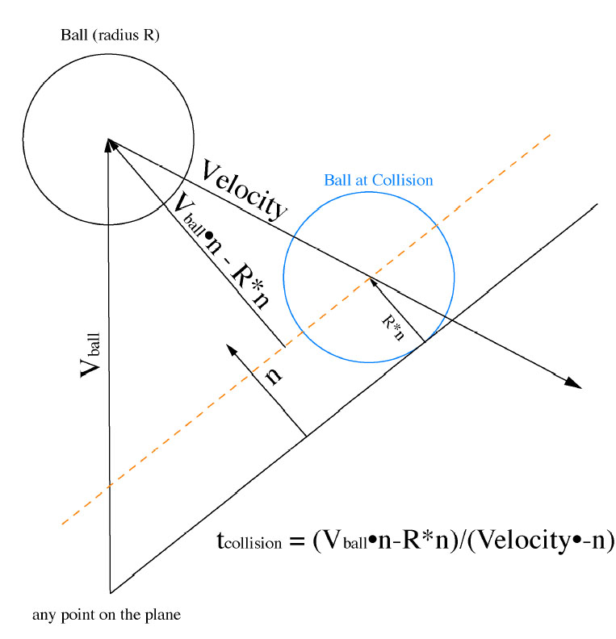
Figure 11: Moving Ball / Non-moving Plane Collision

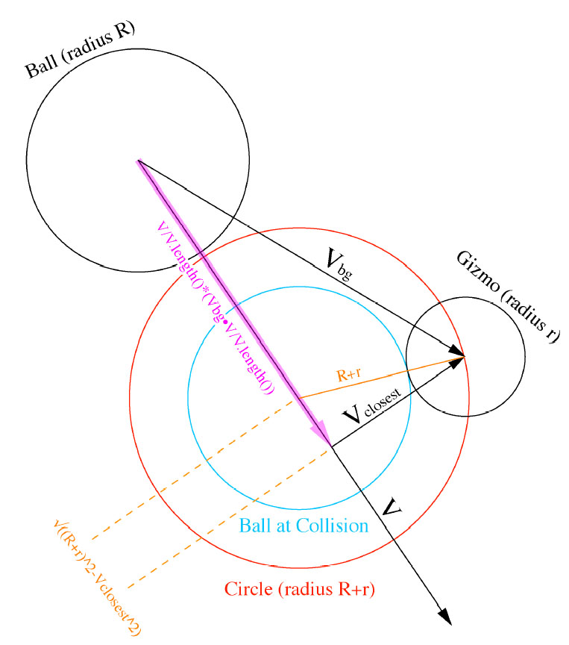
Figure 12: Moving Ball / Non-moving Sphere Collision
Appendix C: Revised Java3D Specifications

EXTERNAL CODE

Several files of code that are used in Gizmoball3D are modified versions of code from external sources. Due to the unique nature of our project, our GUI uses the Java3D API to display all its graphics. Although the API is still in beta, there is a community of Java3D API developers on the Internet. Several of these developers, like www.j3d.org, some tutorial sites, Java3D community bulletin boards, and Sun itself, have written up utility classes for the entire community to use. The utility files are open source and are free for people to use and modify. Since the Java3D API is still in beta (version 1.3 as of 5/2003), the utility classes make it easier for users to use the API. Gizzmoball3D takes advantage of the open source utility classes.

Note: The utility classes that Gizmoball3D uses are non-crucial to the functionality of the program. Permission has been granted by the 6.170 staff to use them. Detailed copyright information has been included at the top of any code that has been borrowed from an external source.

DETAILED DESCRIPTION OF EXTERNAL UTILITY CLASSES

package gui.geometries:

ColorlessCube - a white-colored version of the API's ColorCube primitive

package gui.picking:

MouseRotate - handles rotation of 3D object upon mouse-drag
MouseTranslate - handles translation of 3D object in XY direction upon mouse-drag
MouseZoom - handles translation of 3D object in Z direction upon mouse-drag

package gui.picking.behaviors:

BoundsBehavior - Draws the rectangular bounding box of a 3D object
CollisionDetector - Detects graphics collisions. Note: This is unrelated to actual physical gizmo collisions.
ExplosionBehavior - Makes a 3D object shatter into pieces.
PickHighlightBehavior - Highlights a picked 3D object upon mouse-click
PickHighlightBehavior2 - Highlights a picked 3D object upon mouse-hover
PickRotationBehavior - allows mouse-click picking of 3D object and sets it up for MouseRotate
PickTranslateBehavior - allows mouse-click picking of 3D object and sets it up for MouseTranslate
PickZoomBehavior - allows mouse-click picking of 3D object and sets it up for PickTranslate
PickMouseBehavior - parent class of PickRotation/Translate/Zoom
PickingCallback - helper class for PickMouseBehavior

Note: All of these utility classes deal with Java3D-specific behavior only. Any descriptions that mention "3D object" mean a 3D graphical geometry drawn by Java3D.

VALIDATION AND TESTING OF EXTERNAL UTILITY CLASSES

Due to the nature of GUIs, it is not possible to write permanent, complete test cases to test the code. Validation of any external code is therefore done by exhaustive manual testing of the GUI. For instance, all the mouse and pick related code is validated by actually going into the GUI and clicking the mouse to see if it works. Other code, like BoundsBehavior, is tested via visual confirmation.

Appendix D: Gizmoball Specifications

Syntax
<file> ::= <commandline>*

<commandline> ::= <command>"\n" | "\n"

<command> ::= <gizmoOp> <name> <double-triple> <cor> |
Absorber <name> <double-triple> <double-triple> |
Flipper <name> <double-triple> <cor> <type> |
Ball <name> <double-triple> <double-triple> <double> |
Jezzmo <name> <double-triple> <double> <jezzType> |
Rotate <type> <name> |
Delete <name> |
Move <name> <double-triple> |
Connect <name> <name> |
Connect <name> <name> <action> |
KeyConnect <keyid> <name> |
KeyConnect <keyid> <name> <action> |
MouseConnect <clickId> <name> |
MouseConnect <clickId> <name> <action> |
Gravity <double-triple> |
Friction <double> <double>

<name> ::= IDENTIFIER

<cor> ::= DOUBLE

<type> ::= IDENTIFIER

<gizmoOp> ::= Square | Circle | Triangle | Flipper

<double-triple> ::= DOUBLE DOUBLE DOUBLE

<keyid> ::= "key" KEYNUM "down" |
"key" KEYNUM "up"

<clickId> = <buttonType> <clickType>

<jezzType> = JEZZTYPE

<buttonType> = MOUSENUM

<clickType> = "press" | "release"

<double> ::= DOUBLE

<action> ::= IDENTIFIER

IDENTIFIER represents any string composed only from the characters {'0'..'9','A'..'Z','a..z','_'}. The identifier "OuterWalls" is a special reserved word which refers to the outer walls; no other item may use this identifier
DOUBLE represents any floating point number.
KEYNUM represents any numeric key identifier (which are integers).
MOUSENUM represents any mouse button identifier (see statics in java.awt.event.MouseEvent).
JEZZTYPE represents a valid Jezzmo growth direction (see statics in plugins.pieces.Jezzmo3D).

Gizmoball keywords are case insensitive.

Semantics

"Cube" (IDENTIFIER name) (DOUBLE x) (DOUBLE y) (DOUBLE z) (DOUBLE cor)
"Sphere" (IDENTIFIER name) (DOUBLE x) (DOUBLE y) (DOUBLE z) (DOUBLE cor)
"TriangleA" (IDENTIFIER name) (DOUBLE x) (DOUBLE y) (DOUBLE z) (DOUBLE cor)
"TriangleB" (IDENTIFIER name) (DOUBLE x) (DOUBLE y) (DOUBLE z) (DOUBLE cor)
"TriangleC" (IDENTIFIER name) (DOUBLE x) (DOUBLE y) (DOUBLE z) (DOUBLE cor)
Creates the given gizmo with its lower at (x,y,z), in the default orientation and coefficient of reflection cor. Within the file, the name must be unique, and may be used later to refer to this specific gizmo. The default orientation for each gizmo is:
Cube
none (all orientations are equivalent)
Sphere
none (all orientations are equivalent)
TriangleA
The corner is 0,0,0 to 0,0,1, the angled plane is 1,0,0:0,1,0,:0,1,1:1,0,1 (before translation)
TriangleB
The corner is 0,0,0, the angled plane is 1,0,0:0,1,0,:0,0,1 (before translation)
TriangleC
The corners are 0,0,0; 1,0,0; 0,1,0; 0,0,1, the angled plane is 1,1,0:0,1,1,:1,0,1 (before translation)

"Flipper" (IDENTIFIER name) (DOUBLE x) (DOUBLE y) (DOUBLE z) (DOUBLE cor) (IDENTIFIER orientation)
Creates a flipper with its lower corner at (x1,y1,z1) and coefficient of reflection cor. The pivot is at 0.25,1.75,0.25:0.25,1.75,0.75, and the other end is at 0.25,0.25,0.25:0.25,0.25,0.75 (before translation). "orientation" is not processed. Within the file, the name must be unique, and may be used later to refer to this specific flipper.

"Absorber" (IDENTIFIER name) (DOUBLE x1) (DOUBLE y1) (DOUBLE z1) (DOUBLE x2) (DOUBLE y2) (DOUBLE z2)
Creates an absorber with its lower corner at (x1,y1,z1) and its upper corner at (x2,y2,z2). The second position must be at least (x1+1,y1+1,z1+1). Within the file, the name must be unique, and may be used later to refer to this specific absorber.

"Jezzmo" (IDENTIFIER name) (DOUBLE x1) (DOUBLE y1) (DOUBLE z1) (DOUBLE v) (DOUBLE cor) (IDENTIFIER orientation)
Creates a Jezzmo with its lower corner at (x1,y1,z1), growth velocity v, and growth direction orientation. v must be a positive number and orientation must be one of {Jezzmo3D.X_GROWTH, Jezzmo3D.Y_GROWTH, Jezzmo3D.Z_GROWTH}. Within the file, the name must be unique, and may be used later to refer to this specific Jezzmo.

"Ball" (IDENTIFIER name) (DOUBLE x) (DOUBLE y) (DOUBLE z) (DOUBLE vx) (DOUBLE vy) (DOUBLE vz) (DOUBLE mass)
Creates a ball whose lower corner is (x,y,z), velocity is (vx,vy,vz), and mass is mass. Within the file, the name must be unique, and may be used later to refer to this specific ball.

"Rotate" (IDENTIFIER direction) (IDENTIFIER name)
Performs a 90 degree rotation on the item named name. Note that some items (like the absorber, outer walls, or balls) can not be rotated. Rotating a flipper does not change its bounding box but does change its pivot. "direction" must be one of {"XY","YZ","XZ","YX","ZY","ZX"}.

"Delete" (IDENTIFIER name)
Deletes the item named name. After this operation, the item will no longer exist.

"Move" (IDENTIFIER name) (DOUBLE x) (DOUBLE y) (DOUBLE z)
Moves the gizmo with the given name so that its lower corner is at (x,y,z).

"Connect" (IDENTIFIER producer) (IDENTIFIER consumer)
"Connect" (IDENTIFIER producer) (IDENTIFIER consumer) (IDENTIFIER action)
Makes the gizmo named by consumer a consumer of the triggers produced by the gizmo described by producer. That is, every time a ball hits the producer, the consumer's action (specified by action) will happen. If action is not specified, the default action is triggered.

"MouseConnect" (MOUSENUM button) "press" (IDENTIFIER consumer)
"MouseConnect" (MOUSENUM button) "release" (IDENTIFIER consumer) (IDENTIFIER action)
Makes the item named by consumer a consumer of the trigger produced when the mouse button represented by button is pressed (or released, respectively). The action performed is action, or the default action if action is not specified.

"KeyConnect" "key" (KEYNUM num) "down" (IDENTIFIER consumer)
"KeyConnect" "key" (KEYNUM num) "up" (IDENTIFIER consumer)
"KeyConnect" "key" (KEYNUM num) "down" (IDENTIFIER consumer) (IDENTIFIER action)
"KeyConnect" "key" (KEYNUM num) "up" (IDENTIFIER consumer) (IDENTIFIER action)
Makes the item named by consumer a consumer of the trigger produced when the key represented by num is pressed (or released, respectively). The action performed is action, or the default action if action is not specified.

"Gravity" (DOUBLE gx) (DOUBLE gy) (DOUBLE gz)
Changes the gravity of the board to be (gx, gy, gz) L/sec2. This command overrides any previous setting of gravity. If no Gravity command appears in the file the default value is used.

"Friction" (DOUBLE mu) (DOUBLE mu2)
Changes the global friction constants to be mu and mu2 as described in the friction formula. This command overrides any previous setting of friction. If no Friction command appears in the file the default values is used.

Appendix E: Gizmoball3D User Manual

Running Gizmoball3D
Running Gizmoball3D requires two things:
- A machine that can run Java applications and more specifically, *.jar files.
If you cannot run other standard Java applications, visit http://java.sun.org and
download the Java Runtime Environment for your platform.
- A machine that has the Java3D API installed. If your machine does not have the
API, visit http://java.sun.com/products/java-media/3D/download.html and
download the appropriate Java3D API package for your platform.
If these requirements are met, then you are set. Simply execute Gizmoball3D’s JAR file to start the program.

Getting Acquainted with the Graphical User Interface
After executing the JAR file, a window will appear. This is Gizmoball3D’s graphical user interface (GUI). On the left of the GUI is the list of pieces that you can add to the game. On the bottom-left of the GUI is the gizmo properties panel. Information about the currently selected gizmo will be displayed here. On the bottom-right corner of the GUI are the camera controls. These controls can be used to help you position and navigate the 3D universe’s camera and help you obtain the optimal view. The black region at the top-right of the GUI is the 3D canvas. The canvas is your window to the 3D universe and displays the playing arena. It is here that all the action will take place.

About the 3D Arena
Gizmoball3D is a pure 3D application that uses a full 3D physics package, a 3D engine, and of course, 3D graphics. The usual playing board for a standard Gizmoball implementation is a 20 x 20 grid. Gizmoball3D transforms the “playing field” into a full-fledged 20 x 20 x 20 “playing arena.” The arena is setup in a standard Cartesian coordinate system, where +x is to the right, +y is up, and +z is coming toward the user.

When you first load the program, you will see 3 planes heading out in the +x, +y, and +z directions. Each plane, called a grid wall, is drawn in a 20 x 20 grid layout. A unit of space on each grid represents one unit length in the 3D arena. When navigating a 3D universe, it can be easy to lose your orientation. In order to help you navigate, the grid walls have been color-coded in bright, primary colors:

- The color of the xy-plane: Blue
- The color of the yz-plane: Red
- The color of the xz-plane: Yellow
If at any time you are confused about what are you looking at in the arena, turn on the grid walls. You should then quickly regain your orientation.

Camera Control
At any time, you can manipulate the virtual camera to change your views:
- “P” button: Switches camera to perspective view.
- “XY” button: Switches camera to front view, facing the xy-plane.
- “YZ” button: Switches camera to side view, facing the yz-plane.
- “XZ” button: Switches the camera to top view, facing the xz-plane.
- “Lock” button: toggles between locked parallel-projection views of the F/S/T
view modes and standard perspective-projection.
- “Camera” button: toggles on/off keyboard camera controls.

Free-roaming camera with keyboard controls:
If the Camera button is toggled to the “on” state (the camera picture is shaded), then you will be able to move the camera view around via the Arrow keys on the keyboard.
In order to have even more control, turn off NumLock on your keyboard and use your
keypad to control the camera. With the keypad,
8: zoom-in
2: zoom-out
4: rotate-left
6: rotate-right
PgUp: tilt-up
PgDn: tilt-down

Alt + 4: pan-left
Alt + 6: pan-right
Alt + PgUp: pan-up
Alt + PgDn: pan-down

If you ever zoom away from the arena and get lost, press one of the P/XY/YZ/XZ buttons to re-orient yourself.

Editor Mode
Before you can play a live game of Gizmoball3D, you have to build the game first. You can do this by adding various gizmos to the arena and giving them different properties. You can also change some properties of the arena itself.

Adding a Gizmo:

On the left of Gizmoball3D’s GUI is a list of possible game pieces that you can add to the arena. These game pieces include a ball and various types of gizmos. To add a piece, click on the button of the piece you want to add The gizmo you selected will be created at the origin, along with its bounding box. The new gizmo will have the default properties of its type.

By default, the Gizmos spawn at the origin (0, 0, 0). If you want to change the default
spawning location for all new future gizmos, you can set the location by going to Arena Menu -> Arena Properties -> Gizmo Creation tab.

Editing a Gizmo’s Properties via the 3D Canvas:

Now that you have a gizmo in the arena, you can move it around. Move your mouse over the gizmo you want to edit and the gizmo’s bounding box will be highlighted. Click the gizmo you want to be moved and while holding down the mouse button drag it to a new location. To help facilitate the movement of a gizmo in the arena, the following mouse-button arrangement is used:
- Left-click: Moves the gizmo in the xy-plane.
- Right-click: Moves the gizmo along the z direction.

Note: The mouse does not change even if the view changes. Left-click is in xy-plane and right-click is in z-direction no matter where the camera is.

Bounding Boxes and Invalid Gizmo Placement:

Every gizmo has a bounding box which is drawn in a white outline. When you hover your mouse over the gizmo, the bounding box will be highlighted. When you click the gizmo, the gizmo itself will be highlighted. When a gizmo’s bounding box intersects another gizmo’s bounding box, both of the gizmos’ bounding boxes will turn red. This indicates that you have made an invalid placement. If you try to place a gizmo when it is in a red zone, it will pop back to where you first selected it. Also, if you drag the gizmo outside of the 20 x 20 x 20 playing arena, it will have the same behavior.

If you try to spawn a gizmo and another gizmo is blocking its potential spawning location, you will get an error dialog telling you that you cannot spawn a gizmo there.

If you try to load up a Gizmoball game file with over-lapping gizmos or out-of-bounds gizmos, you will get an error dialog telling you to correct the file.

If for some reason graphics collisions are detected and you press “Play”, you will be warned about the collisions. It is highly recommended that you go back to Editor mode to fix your gizmo placements. However, you will still have the option of continuing play, but correct behavior is no longer guaranteed.

Editing a Gizmo’s Properties via the Gizmo Properties Panel:

When you click on a gizmo, its properties panel will show up on the bottom of the GUI. In here, some of the current gizmo’s properties can be changed, such as coefficient of reflection. If you don’t enter a number in the text fields and press Update, you will see a dialog warning you not to correct your mistake.

You can add key triggers to gizmos and connect action commands between gizmos.
To do this, click on the Triggers button. A dialog will pop up. To set keyboard press/release and mouse press/release triggers for the gizmo, press the appropriated button. A small mini-dialog will pop up asking you to press the key or button that you want to use. You will also be able to then link the key to an action. To remove a trigger that you already set, simply press the Remove button. To connect this gizmo with another gizmo, simply select the Connect button in the dialog. The dialog will then disappear, and the next gizmo you click will be the target gizmo. You can then set the actions of this target gizmo.

To change the appearance of a gizmo, simply click the Appearance button. In here, you can set the color, shading type, transparency, and also texture mapping.

For certain gizmos, you can set its Orientation. For these gizmos, click the Orientation button. A mini-dialog will pop up asking you to choose the gizmo’s orientation.

After making your changes, hit the “Update” button to commit the changes you made.

To remove a gizmo, click the “Remove Gizmo” button.

Starting a new Arena:

To start a new arena, in the menu, select File -> New Arena

Play Mode
When you are done editing your game, press the “Play” button to start the game.
Play around with the camera controls to get the view you want.
Press the key/mouse bindings that you made in Edit mode to trigger the actions you specified.
To pause the game, press the “Pause” button.
To stop the game, press the “Stop” button. This will reset the gizmos to their previous state.
To exit back to Edit mode, press the “Back to Editor” button.

Loading and Saving Games
Loading a Gizmoball3D Arena in the standard 6.170 file format:
In the menu, select File -> Load. A dialog will pop up for you to select the file you want to load.

Loading a Gizmoball3D Arena in the customized *.g3d file format:
In the menu, select File -> Load *.g3d. A dialog will pop up for you to select the file you want to load.

Saving a Gizmoball3D Arena:
In the menu, select File -> Save As *.g3d. A dialog will pop up for you to save the file.

Other Menu Options
Drawing the Grid Walls: Draws the grid walls.
Draw the Outer Wall Gizmos: Displays the outer wall gizmos that bound the arena.
Switching between Wireframe drawing and Polygonal drawing: Toggles drawing modes.
Snapping to Grid: Toggles snap-to-grid alignment for gizmo placement.

Arena Properties: You can modify various arena settings here, such as gravity, friction values, default gizmo spawning locations, and the frames per second (FPS) for Play mode.

Getting Help
When you hover your mouse over a button, a “mouse tip” will pop up and give a brief text description of the button. To turn of this feature, uncheck the box.

Exiting Gizmoball3D
In the menu, select File -> Exit.
Appendix F: Gizmoball Specifications

Please refer to the java documentation for complete specifications of the Gizmoball system.

Design Patterns are used as described in the Design Patterns: Elements of Reusable Object-Orientated Software by Gamma, Helm, Johnson, and Vlissides

